**User Manual**

**Executable File Installation Guide:**

The installation guide is for Windows. The executable is Windows-only. Install and launch the program using these steps:

***Step 1: Running the Executable File***

Find the received executable. Double-click the file to install. Upon startup, a setup window appears.

***Step 2: Choosing Installation Destination***

Select a target folder for the program in the setup box. You can pick the normal installation directory or a custom system location. Click "Next" to continue.

***Step 3: Initiating Installation***

After selecting the installation location, click "Next" to begin installation. The installation will now copy files and components to the chosen place on your machine.

***Step 4: Completing Installation***

After installation, a "Finish" button appears. Click "Finish" to finish installation.

***Step 5: Application Access***

Go to the app's installation folder. The installation location is normally under "Program Files" on your system disk (C:). Find the application file in the folder.

***Step 6: Application Launch***

Launch the game by double-clicking the program. Your application's user interface will display its features and settings.

***Step 7: Gameplay Guide***

The program lets you control a single-player character. The system will control other players, making the game entertaining for solo players.

**User Interface Layout:**

According to the specified layout, the game's user interface will be structured. It will have parts and components that improve playability.

*Figure 1: User interface.*

Users can select play option to play with default mode. Users can also check scores achieved in previous games. Users can select their difficulty level using this menu.

In Medium and Hard, users can choose grid size from this option.

With the Easy Mode Settings, the user will see a menu with just three options.

The following figure shows the game's grid. These squares form the basis of the playing field. The immersive nature of the game is a result of the opportunity for different interactions, decisions, and results in each cell of the grid.

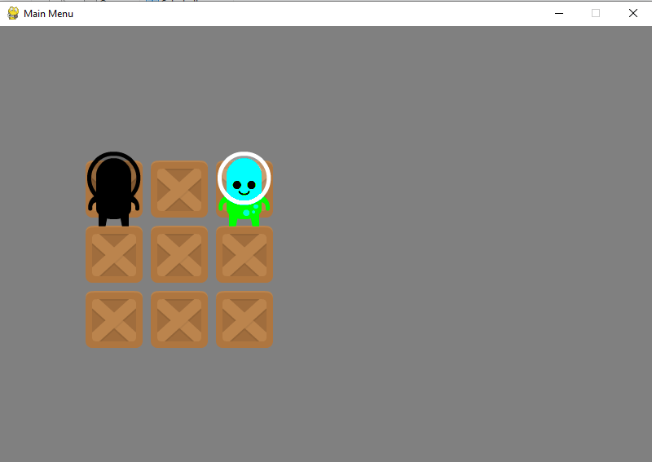

When both players have reached the same location on the game board, the game will end, and the menu will reset.